**INDEX**

|  |  |
| --- | --- |
| **Chapter** | **Page No.** |
| 1. **Introduction to LI-FI Technology**    1. **Standardization**    2. **Visible** **Light Communication** 2. **LI-FI Fundamentals**    1. **Genesis of LI_FI**    2. **Issue Regarding Radio Spectrum** 3. **Technology Brief**    1. **Li-Fi Construction**    2. **Modulation** 4. **Economic Value and Limitation**    1. **Economic Value**    2. **Economic Limitation** 5. **Application Area of Li-Fi Technology**    1. **Airways**    2. **Undersea Awesomeness**    3. **Traffic Signals** 6. **Li – Fi Challenges and Solutions**    1. **Challenging Problem**    2. **Solution to Challenging Problem** 7. **Advantages**    1. **Proficiency**    2. **Cost**    3. **Security**    4. **High speed** 8. **Conclusion** 9. **References** | **3**  4  5  **7**  8  8  **11**  12  14  **15**  16  16  **17**  18  19  20  **21**  22  22  **25**  26  26  26  26  **28**  **30** |

**ABSTRACT OF LI-FI - TECHNOLOGY**

* Whether you’re using wireless internet in a coffee shop, stealing it from the guy next door or competing for bandwidth at a conference, you’ve probably gotten frustrated at the slow speeds you face when more than one device is tapped into the network.
* As more and more people and their many device access wireless internet, clogged airwaves are going to make it increasingly difficult to latch onto a reliable signal. But radio waves are just one part of the spectrum that can carry our data.

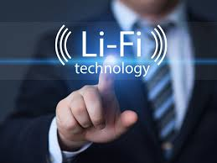

# 1. Introduction

1.1 Standardization

1.2 Visible Light Communication

* Li-Fi (Light Fidelity) is a fast and cheap optical version of Wi-Fi, the technology of which is based on Visible Light Communication (VLC). LiFi is transmission of data through illumination by taking the fiber out of fiber optics by sending data through a LED light bulb that varies in intensity faster than the human eye can follow.

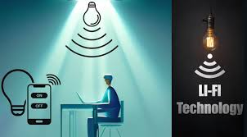

* 1. **Standardization**
* VLC communication is modeled after communication protocols established by the IEEE 802 workgroup. This standard defines the physical layer (PHY) and media access control (MAC) layer.

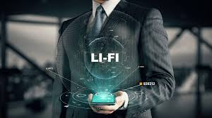

**1.2** **Visible Light Communications**

Visible light Communication (VLC) is a modern communication technology which employs visible solid-state light sources (LEDs) for transmitting data wirelessly as they are used for general illumination at the same time.

**VLC Characteristics**

The merits and demerits of this technology become apparent once we go through the characteristics of visible light communication technology

* **Human Safety**

VLC poses no health hazards to human body. Thus, theϖ transmission power can be kept high if needed.

* **High Data Rates**

VLC inherits high data rates from optical communications. Thus, it can be used for very high speed wireless communications.

* **Bandwidth**

Visible light communications exploits the visible region of electromagnetic spectrum. Thus it much larger frequency band ( 300 THz) compared to that available in RF communications ( 300GHz).

* **Security**

As VLC involves line of sight communication, so it is impossible to tap the communication without breaking the link. So it a very secure communication and can be used in high security military areas where RF communication is prone to eavesdropping.

* **Visibility**

It is aesthetically pleasing to see data being communicated byϖ colored lights. Thus, VLC is also used in many entertainment related activities like silent concerts, decoration systems, etc.

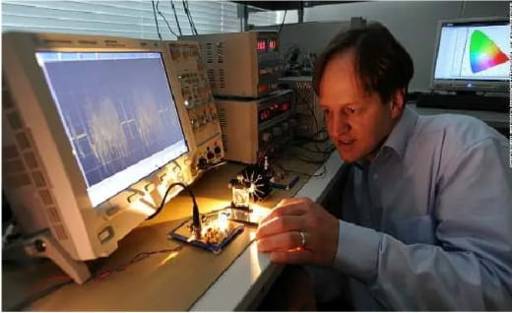

**2. LI-FI Fundamentals**

2.1 Genesis of LI-FI

2.2 Issues Regarding

Radio - spectrum

**2. 1 Genesis of LI-FI**

* Harald Haas, a professor at the University of Edinburgh who began his research in the field in 2004, gave a debut demonstration of what he called a Li-Fi prototype at the TED Global conference in Edinburgh on 12th July 2011.

* Back in 2011 German scientists succeeded in creating an 800Mbps (Megabits per second) capable wireless network by using nothing more than normal red, blue, green and white LED light bulbs, thus the idea has been around for awhile and various other global teams are also exploring the possibilities

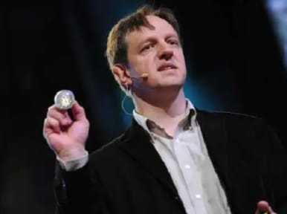

* 1. **Issues Regarding Radio-spectrum**

Radio Spectrum is congested but the demand for wirelesses data double each year. Everything, it seems want to use wireless data but the capacity is drying up.

* **Capacity**

In LI-FI the Bandwidth is 10000 times more than radio wave. That provides huge range of spectrum bandwidth.

* **Efficiency**

Millions of base stations for radio wave transmission and receiving on the earth consume huge amount of energy for transmitting the radio waves and to cool the base station cabins.

* **Security**

Radio wave penetrates walls which cause security laps. Any one access to the private network of any one and use their data, login to their secure region.

* **VLC V/S RF Communication**
* **Limited Transmission Power**

In RF communications, the electric transmission power cannot be increased beyond a prescribed level as it poses serious health hazards for human body.

* **Regulated Spectrum**

Due to the radio wave restriction, there is no room to use more radio frequencies. In addition, the use of radio spectrum is regulated.

* **Banned in Sensitive Areas**

The radio wave cannot be used in hospitals and Space stations because it adversely acts the performance of precision instruments. These radio wave problems above are easily solved by use of the visible light

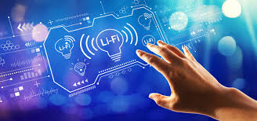.

1. **Technology Brief**

3.1 LI-FI CONSTRUCTION

3.2 Modulation

**3.1**  **LI-FI CONSTRUCTION**

The LI-FI™ product consists of 4 primary sub-assemblies :

• Bulb

• RF power amplifier circuit (PA)

• Printed circuit board (PCB)

• Enclosure

The PCB controls the electrical inputs and outputs of the lamp and houses the microcontroller used to manage different lamp functions. An RF (radio-frequency) signal is generated by the solid-state PA and is guided into an electric field about the bulb.

**Transmitters**

The following components are used at the transmitting side:

1. Colored LEDs

2. Mosfets

3. RS232 line driver IC

4. USB to RS232 coverter cable

5. Voltage Regulator

**Colored LEDs**

* An array of Red, Green and Blue LEDs are used at the transmitter end as visible light sources. They are connected as loads in the transistor circuitry. They are high power and emit a focused beam. Each color is used to carry a different data stream.

**MOSFETs**

* A high speed N-type power MOSFET IRF 520 is used to modulate the LEDs using OOK (On off Keying). The serial output from the computer is converted into TTL Compatible form and is then applied to the gate of the transistor. Thus, it switches the load (LEDs) on and off in accordance with the input data 4.3.1.3 RS232 line driver.

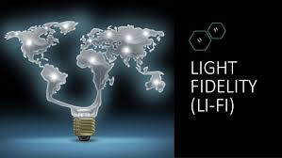

**Modulation**

* In order to actually send out data via LEDs, such as pictures or audio files, it is necessary to modulate these into a carrier signal. In the context of visible light communication, this carrier signal consists of light pulses sent out in short intervals.
* How these are exactly interpreted depends on the chosen modulation scheme, two of which will be presented in this section. At first, a scheme called subcarrier pulse position modulation is presented which is already established as VLC-standard by the VLCC. The second modulation scheme to be addressed is called frequency shift Keying, commonly referred to as FSK. They also explore how to combine pulse-position modulation with illumination control.

**4. Economic value and Limitations**

4.1 Economic value

4.2 Economic Limitation

* 1. **Economic value**
* High installment cost but very low maintenance cost.
* Cheaper than Wi-Fi.
* Theoretical speed up to 1 GB per second : Less time & energy consumption.
* No more monthly broadband bills.
* Lower electricity costs.
* Longevity of LED bulb: saves money.
* Light doesn't penetrate through walls: secured access.
  1. **Economic Limitations**
* The main problem is that light can't pass through objects, so if the receiver is inadvertently blocked in any way, then the signal will immediately cut out. "If the light signal is blocked, or when you need to use your device to send information -- you can seamlessly switch back over to radio waves", Harald says. Reliability and network coverage are the major issues to be considered by the companies while providing VLC services.
* Interferences from external light sources like sun light, normal bulbs; and opaque materials in the path of transmission will cause interruption in the communication. High installation cost of the VLC systems can be complemented by large-scale implementation of VLC though Adopting VLC technology will reduce further operating costs like electricity charges, maintenance charges etc.

1. **Application area of LI-FI technology**
   1. Airways
   2. Undersea Awesomeness
   3. Traffic Signals

**5.1 Airways**



* Whenever we travel through airways we face the problem in communication media, because the whole airways communication are performed on the basis of radio waves.
* To overcome this drawback on radio wave, li-fi is introduced.
  1. **Undersea Awesomeness**



* Underwater ROVs, those favourite toys of treasure seekers and James Cameron, operate from large cables that supply their power and allow them to receive signals from their pilots above.
* ROVs work great, except when the tether isn’t long enough to explore an area, or when it gets stuck on something. If their wires were cut and replaced with light — say from a Submerged, high-powered lamp — then they would be much free to explore.
* They could also use their headlamps to communicate with each other, processing data autonomously and referring findings periodically back to the surface, all the while obtaining their next batch of orders.

**5.3 Traffic Signals**

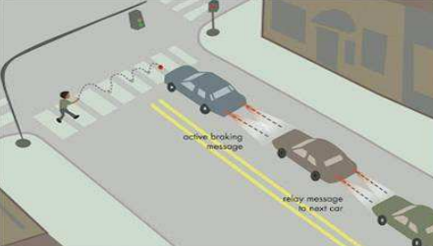

* In traffic signals Li Fi can be used which will communicate with the LED lights of the cars and accident numbers can be decreased. Thousand and millions of street lamps can be transferred to LiFi lamps to transfer data.

**6. LI-FI : Challenges and Solutions**

6.1 LI-FI Challenging Problems

6.2 Solutions to Challenging Problems

* **Challenging Problems**
* Connectivity while moving
* Multiuser support
* Dimming
* Shadowing
* **Solutions to Challenging problems**
* **Solution for connectivity**
* This problem is similar to the connectivity problem in cellular network when you move from one area of the city to another area while speaking with cell-phone.
* The solution is called “handover”, using which the user is transferred from one BS to another Handover is done in the area that two BS’s have common coverage.

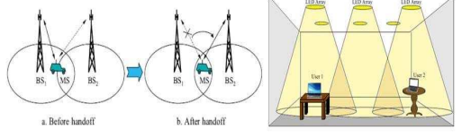

* **Solution for multiuser support**
* In this problem one solution is time division multiplexing (TDM). Each frame is divided into equal time slots.
* Each user transmits data in one time slot in a predefined order. The other solution is code division multiple access (CDMA).
* Codes are assigned to users. Each user transmits its data using the assigned signature pattern .

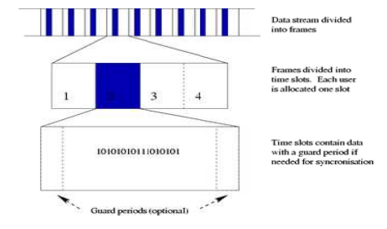

* **Solution for shadowing**

As shown before, the impulse response in VLC system has two parts. When the line-of-sight(LOS) part (which is received via direct path) is blocked, the impulse response is only the second part. Then the data can be recovered using the second part which is indeed the received data from the indirect paths(multipath signal)

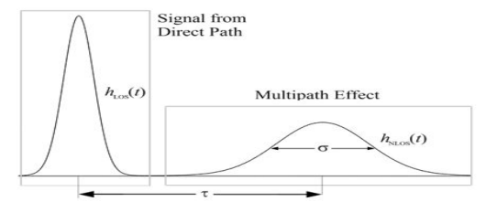

**7. Advantage of Li-Fi Technology**

7.1 Proficiency

7.2Cost

7.3 Security

7.4 High speed

* **Advantages of Li-Fi Technology**
* **Proficiency**

Energy utility can be minimised with use of LED illumination which are now accessible in home, workplaces and Mall and so on for lighting reasons. Consequently transmission of information requiring negligible additional power, which makes it efficient in terms of costs as well as energy.

* **Cost**

Not only does Li-Fi need fewer components for its service, but it also requires only small additional capacity for data transmission.

Availability is not issue as light sources are available all over place. Along these lines, lights are can be utilized as model for information transmission.

* **Security**

One principal advantage of Li-Fi is security. Since light can’t go through opaque structures, Li-Fi web is accessible just to clients inside limited zone and can’t be intercepted and misused, outside area under operation.

* **Highspeed**

   
Combination of low interference, high bandwidths and high-intensity output, aids Li-Fi provides high data rates i.e., 1 Gbps or even beyond.

**8. CONCLUSION**

* **CONCLUSION**
* The possibilities are numerous and can be explored further. If his technology can be put into practical use, every bulb can be used something like a Wi-Fi hotspot to transmit wireless data and we will proceed toward the cleaner, greener, safer and brighter future.
* The concept of Li-Fi is currently attracting a great deal of interest, not least because it may offer a genuine and very efficient alternative to radio-based wireless.
* As a growing number of people and their many devices access wireless internet, the airwaves are becoming increasingly clogged, making it more and more difficult to get a reliable, high-speed signal.
* This may solve issues such as the shortage of radio-frequency bandwidth and also allow internet where traditional radio based wireless isn’t allowed such as aircraft or hospitals.
* One of the shortcomings however is that it only work in direct line of sight.
* **References**

en.wikipedia.org/wiki/Li-Fi

http://www.digplanet.com/wiki/Li-Fi